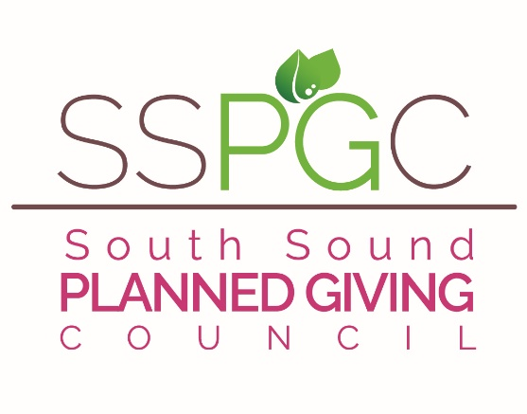
SUMMIT SPECIAL

2022-23 SSPGC 15 for 12 Special – Just $75.00
15 mos. For the price of 12! – Membership is good thru Dec. 2023

Your SSPGC Board is hard at work again this year. We currently conduct 10 lunch-hour presentations on
the SSPGC ZOOM platform with timely information and ideas with both local experts and occasionally a national speaker. These sessions inform and educate several hundred cohorts each year and bring the art of Planned Giving to life.. We have increased the number of allied professions (Lawyers, CPAs, CFPs, Trust Officers, CFREs, CAPs, etc.) in our membership which has added tremendously to the width and depth of our discussions and knowledge base.

There are many opportunities for your participation in hosting, presenting and planning for the various activities of the year. Your involvement and comments are always appreciated and solicited. We are continually seeking members who have an interest in board membership and in helping the Council grow.

Benefits of membership include:

1. Membership Luncheons with timely topics held on ZOOM right now, but will move to local facilities when it is safe to do so. When in-person, Members pay $20 - Non-member Fee is $30

2. FREE Brown-bag-lunch discussions and Panels with local professionals who bring updated information and valuable insights, education and training to the Planned Giving community in the South Sound.

3. SSPGC and AFP together presented our our famous South Sound Philanthropy Summit with two national speakers. Response has been overwhelmingly positive and this is our 10 year Anniversary!

4. Opportunities to meet colleagues and create lasting professional relationships with both planned giving officers and professionals in allied professions that all work together to create successful donor experiences.

5. The opportunity to learn from and teach each other as well as lead SSPGC in its quest to provide pertinent programs for its members . Help the general level of knowledge in our community and lend your expertise to conversations and presentations.

6. Reciprocal membership privileges with Washington Planned Giving Council in Seattle – WPGC member luncheon pricing as well as member pricing to their Conferences (and our member prices are reciprocated to their members) – Association of Fundraising Professionals (AFPSS) members receive a $25 reduction for dual membership ($50 per calendar year.)

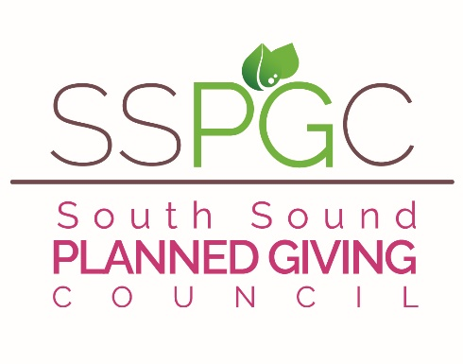
There are many more benefits to this Council – we truly hope you will join us again this year in making the South Sound Planned Giving Council an organization that is responsive and relevant to the professional and educational needs of this growing and vital giving method called Planned Giving.
2022-23 Membership Form – New Member Dues are $75
Good through thru December 2023
SUMMIT SPECIAL
--FOR OFFICE USE ONLY--

Amount paid: Date paid:
Check#: Cash:

Mailing list Email list Directory

Complete this form and return it with your payment to:
S.S.P.G.C.
Rick Oldenburg
6825 Rainier Ave
Gig Harbor, WA 98335

Make checks payable to South Sound Planned Giving Council (SSPGC)

Name:_______________________________________________________________

Job Title: _____________________________________________________ __

Business Affiliation: ____________________________________________ __
Business Address: ______________________________________________ __

_______________________________________________ __

Bus. Phone: __________________________ FAX: __________________________

Cell: ________________________________ Other: _________________________

E-mail Address: ______________________________________________________

Referred by: _________________________________________________________

Is there someone else you think should be invited to join SSPGC? Please share their name and organization…we will follow up!

____________________ ________________________ _____________
Name Organization Phone#

I AM INTERESTED IN BOARD SERVICE ___YES ___NO ___MAYBE

