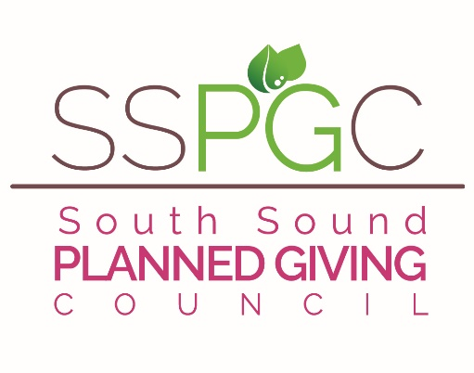

S P E C I A L P R I C E

2023 SSPGC Early Bird Renewals is now ON!
RENEWING Members just $50 through December!

Membership Remains $75 for 2023!

Your SSPGC Board is hard at work even as the Pandemic winds on. We are working to provide educational and interactive opportunities for you to learn and ask questions of our presenters, panelists and audience members. We will conduct 10 Lunch presentations in 2023, hopefully four in-person meetings and some on the ZOOM platform. These sessions inform and educate several hundred cohorts each year and involve local, regional and national experienced professionals. We have increased the number of allied professions (Lawyers, CPAs, CFPs, Trust Officers, CFREs, CAPs, etc.) in our membership which has added tremendously to the width and depth of our discussions and knowledge base.
There are many opportunities for your participation in hosting, presenting and planning for the various activities once we are no longer in the midst of a pandemic. Your involvement and comments are always appreciated and solicited. We are continually seeking members who have an interest in board membership and in helping the Council grow.

Benefits of membership include:

1. RESUMING IN-PERSON MEETINGS (conditions allowing) - Membership in-person Luncheons with timely topics held at La Quinta Inn & Suites. Members pay $20 - Non-member Fee is $30

2. At least four Brown Bag Lunch discussions and/or Panels with local professionals who bring updated information, valuable insights, education and training to the Planned Giving community in the South Sound.

3. SSPGC and AFP together will present our 11th day-long South Sound Philanthropy Summit with national speakers. Response is always positive, so plan to join us on September 29, 2023 for the next Summit.

4. Opportunities to meet colleagues and create lasting professional relationships with both planned giving officers and professionals in allied professions that all work together to create successful donor experiences.

5. The opportunity to learn from and teach each other as well as lead SSPGC in its quest to provide pertinent programs for its members . Help the general level of knowledge in our community and lend your expertise to conversations and presentations.

6. Reciprocal membership privileges with Washington Planned Giving Council in Seattle – WPGC member luncheon pricing as well as member pricing to their Conferences (and our member prices are reciprocated to their members) – Association of Fundraising Professionals (AFPSS) members receive a $25 reduction for dual membership ($50 per calendar year.)

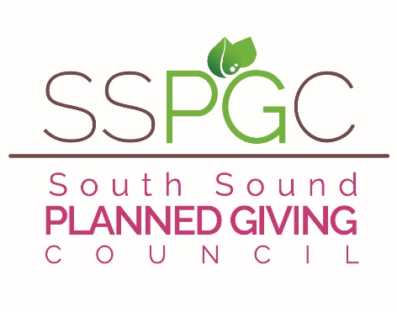
There are many more benefits to this Council – we truly hope you will join us again this year in making the South Sound Planned Giving Council an organization that is responsive and relevant to the professional and educational needs of this growing and vital giving method called Planned Giving.
EARLY BIRD SPECIAL
2023 Membership Form – Dues are normally $75
EARLY BIRD RENEWAL – JUST $50 Thru December!
PLEASE MAIL TO ADDRESS BELOW!
--FOR OFFICE USE ONLY--

Amount paid: Date paid:
Check#: Cash:

Accounting Gmail Directory

Complete this form and return it with your payment to:
S.S.P.G.C.
Rick Oldenburg, CAP
6825 Rainier Ave
Gig Harbor, WA 98335

Make checks payable to South Sound Planned Giving Council (SSPGC)

Name:________________________________________________________________

Job Title: _____________________________________________________________

Business Affiliation: ____________________________________________________

Business Address: ________________________________ City_________Zip______

Bus. Phone: ___________________________ Cell: __________________________

Professional Designations (JD,CPA,CAP,CFP): ____________________________

E-mail Address: _______________________________________________________

Referred by: __________________________________________________________

Permission to list you in on-line members only directory (yes/no) :__________

Is there someone else you think should be invited to join SSPGC? Please share their name and organization…we will follow up!

____________________ ________________________ _____________
Name Organization Phone#

I AM INTERESTED IN BOARD SERVICE ___YES ___NO ___MAYBE

